Ideation Phase
Brainstorm & Idea Prioritization Template

Date | 01 November 2025
Team ID | NM2025TMID00926
Project Name | Streamlining Ticket Assignment For Efficient Support Operations
Maximum Marks | 4 Marks

Brainstorm & Idea Prioritization Template:
Step-1: Team Gathering, Collaboration and Select the Problem Statement

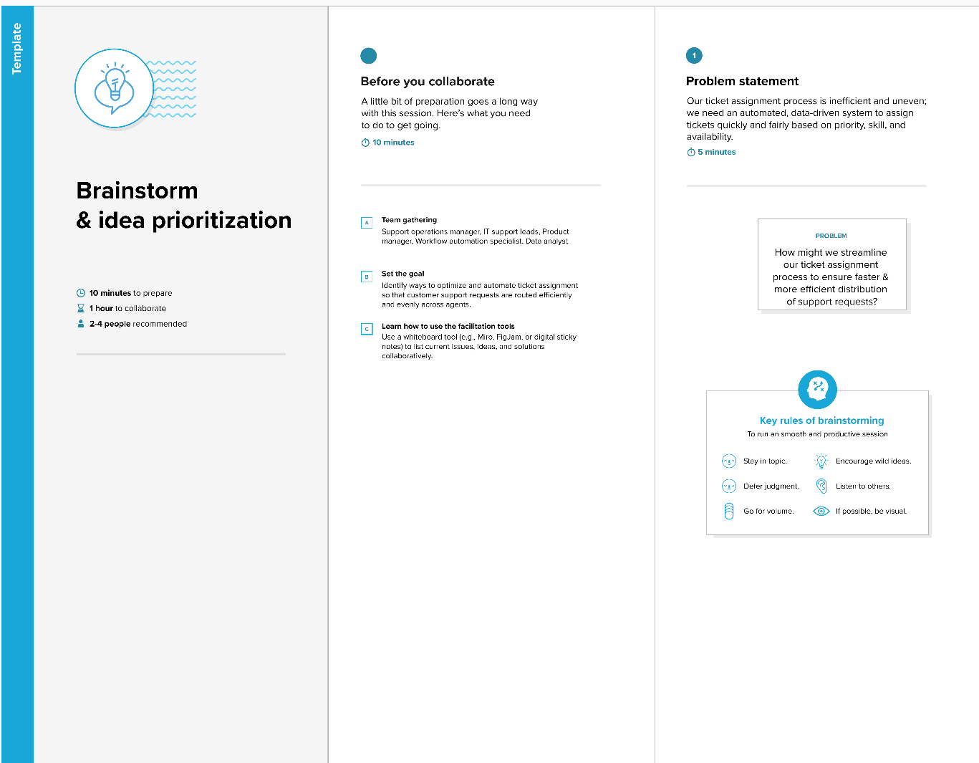

Step-2: Brainstorm, Idea Listing and Grouping
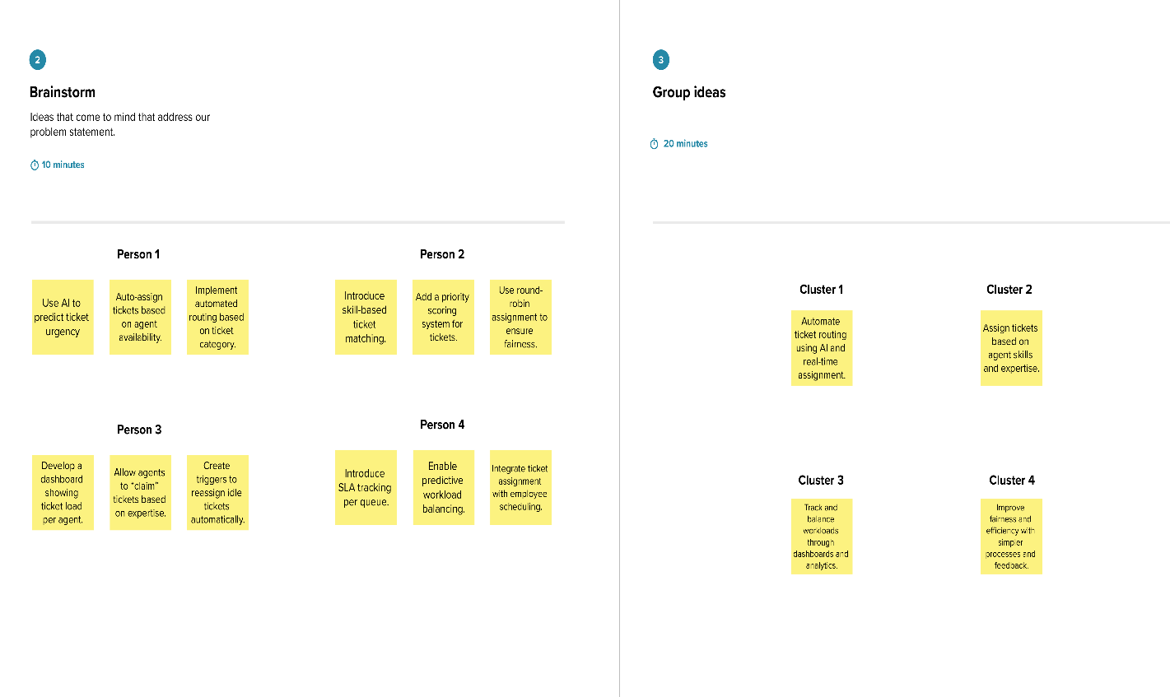
Step-3: Idea Prioritization